**B.M.S. COLLEGE OF ENGINEERING**

Basavanagudi, Bengaluru- 560019

**DEPARTMENT OF COMPUTER SCIENCE AND ENGINEERING**

**LAB REPORT**

On

***Object Oriented Java Programming***

**(23CS3PCOOJ)**

Submitted By :

**DHEEMANTH M**

**1BM22CS087**

*In partial fulfilment of*

**BACHELOR OF ENGINEERING**

In

**COMPUTER SCIENCE AND ENGINEERING**

2023-24

Faculty-In-Charge [**Shravya A R**](https://bmsce.ac.in/home/facultyProfile/530/Karanam-Sunil-Kumar-)

**Assistant Professor**

**Department of Computer Science and Engineering**

**LAB-1**

/*Develop a Java program that prints all real solutions to the quadratic equation

ax2+bx+c = 0. Read in a, b, c and use the quadratic formula. If the discriminate b2-4ac

is negative, display a message stating that there are no real solutions.*/

import java.util.Scanner;

class Quadratic {

int a, b, c;

double d, r1, r2;

void QuadCalc(int a, int b, int c) {

d = b * b - (4 * a * c);

if (d < 0) {

System.out.println("There are no real solutions");

} else if (d > 0) {

r1 = (-b + Math.sqrt(d)) / (2 * a);

r2 = (-b - Math.sqrt(d)) / (2 * a);

System.out.println("Roots are " + r1 + " and " + r2);

} else if (d == 0) {

r1 = r2 = -b / (2.0 * a);

System.out.println("Equal roots: " + r1);

}

}

}

public class Lab1 {

public static void main(String[] args) {

System.out.println("Dheemanth M");

System.out.println("1BM22CS087");

Scanner s = new Scanner(System.in);

Quadratic q = new Quadratic();

System.out.println("Enter coefficients a, b, c:");

int a = s.nextInt();

int b = s.nextInt();

int c = s.nextInt();

q.QuadCalc(a, b, c);

}

}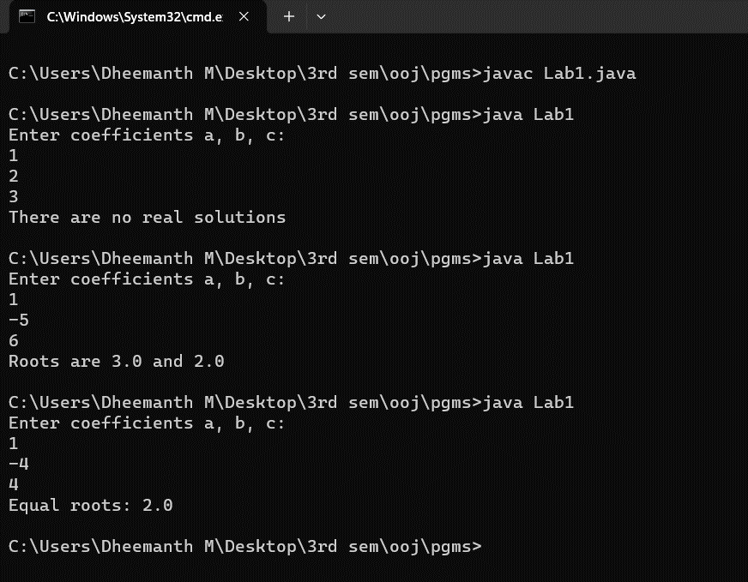

**LAB-2**

/*Develop a Java program to create a class Student with members usn, name, an array

credits and an array marks. Include methods to accept and display details and a

method to calculate SGPA of a student. */

import java.util.Scanner;

class Student {

String usn, name;

int[] credits;

int[] marks;

int size;

void accept() {

Scanner s = new Scanner(System.in);

System.out.println("Enter name:");

name = s.nextLine();

System.out.println("Enter usn:");

usn = s.nextLine();

System.out.println("Enter number of subjects:");

size = s.nextInt();

credits = new int[size];

marks = new int[size];

for (int i = 0; i < size; i++) {

System.out.println("Enter Subject " + (i + 1) + " marks:");

marks[i] = s.nextInt();

System.out.println("Enter credits for Subject " + (i + 1) + ":");

credits[i] = s.nextInt();

}

}

float calculate() {

float sgpa = 0;

int totalCredits = 0;

for (int i = 0; i < size; i++) {

sgpa += (marks[i] / 10) * credits[i];

totalCredits += credits[i];

}

sgpa /= totalCredits;

return sgpa;

}

void display() {

System.out.println("Name: " + name);

System.out.println("USN: " + usn);

for (int i = 0; i < size; i++) {

System.out.println("Subject " + (i + 1) + " Marks: " + marks[i]);

}

System.out.println("SGPA: " + calculate());

}

}

public class Lab2 {

public static void main(String[] args) {

System.out.println("Dheemanth M");

System.out.println("1BM22CS087");

Student s = new Student();

s.accept();

s.display();

}}

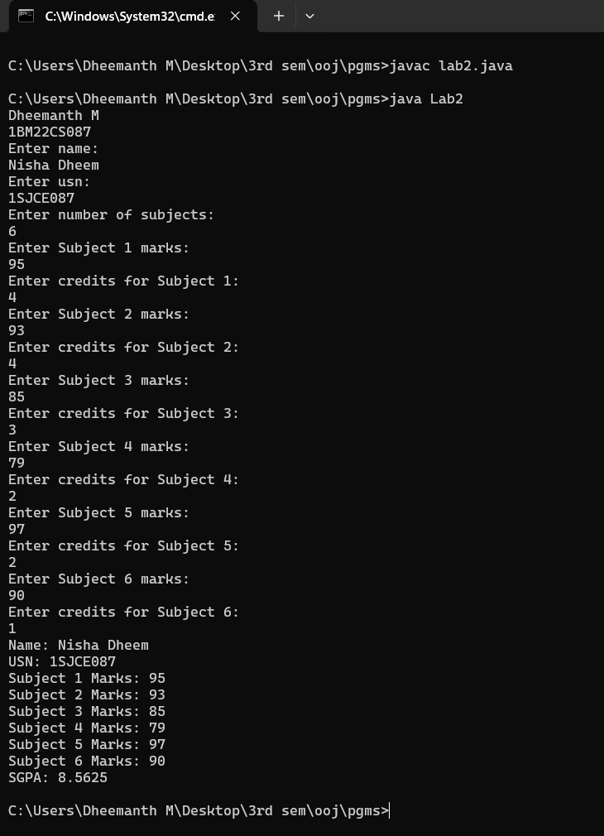

**LAB-3**

/*Create a class Book which contains four members: name, author, price, num_pages.

Include a constructor to set the values for the members. Include methods to set and

get the details of the objects. Include a toString( ) method that could display the

complete details of the book. Develop a Java program to create n book objects.*/

import java.util.Scanner;

class Book {

String bookname;

String author;

int price, pages;

Book(String bookname, String author, int price, int pages) {

this.bookname = bookname;

this.author = author;

this.price = price;

this.pages = pages;

}

public void setBookname(String bookname) {

this.bookname = bookname;

}

public void setBookauthor(String author) {

this.author = author;

}

public void setPrice(int price) {

this.price = price;

}

public void setPages(int pages) {

this.pages = pages;

}

public String getBookname() {

return bookname;

}

public String getBookauthor() {

return author;

}

public int getPrice() {

return price;

}

public int getPages() {

return pages;

}

public String toString() {

return "Book name: " + bookname + "\nAuthor: " + author + "\nPrice: " + price + "\nPages: " + pages;

}

}

class Lab3 {

public static void main(String[] args) {

Scanner s = new Scanner(System.in);

System.out.println("Enter number of books");

int size = s.nextInt();

s.nextLine();

Book[] b = new Book[size];

for (int i = 0; i < size; i++) {

System.out.println("Enter name of Book " + (i + 1));

String bookname = s.nextLine();

System.out.println("Enter author of Book " + (i + 1));

String author = s.nextLine();

System.out.println("Enter price of Book " + (i + 1));

int price = s.nextInt();

System.out.println("Enter pages of Book " + (i + 1));

int pages = s.nextInt();

s.nextLine();

b[i] = new Book(bookname, author, price, pages);

}

for (int i = 0; i < b.length; i++) {

System.out.println("Book " + (i + 1) + ":\n" + b[i].toString());

}

}

}

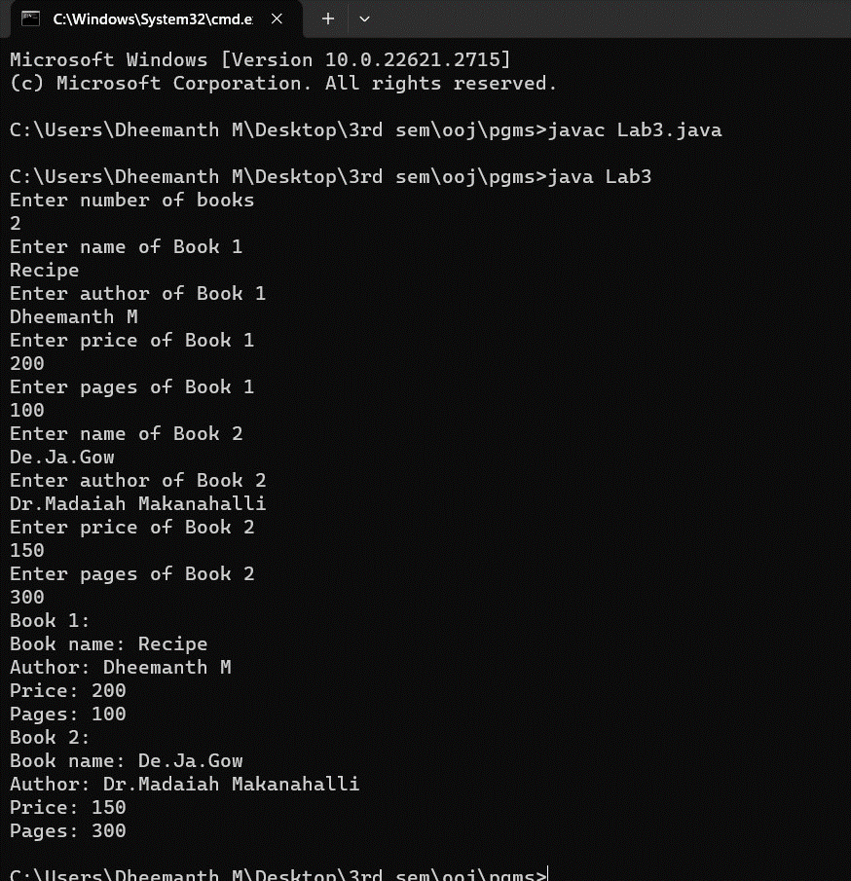.

**LAB-4**

/*Develop a Java program to create an abstract class named Shape that contains two integers and an empty method named printArea( ). Provide three classes named Rectangle, Triangle and Circle such that each one of the classes extends the class Shape. Each one of the classes contain only the method printArea( ) that prints the area of the given shape*/

import java.util.Scanner;

abstract class Shape {

public int a, b;

public abstract void printArea();

}

class Rectangle extends Shape {

Rectangle(int a, int b) {

this.a = a;

this.b = b;

}

public void printArea() {

System.out.println("Rectangle area is: " + (a * b));

}

}

class Triangle extends Shape {

Triangle(int a, int b) {

this.a = a;

this.b = b;

}

public void printArea() {

System.out.println("Triangle area is: " + (0.5 * a * b));

}

}

class Circle extends Shape {

Circle(int a) {

this.a = a;

}

public void printArea() {

System.out.println("Circle area is: " + (Math.PI * a * a));

}

}

public class Lab4 {

public static void main(String[] args) {

System.out.println("Dheemanth M");

System.out.println("1BM22CS087");

Scanner s = new Scanner(System.in);

System.out.println("Enter length and breadth of rectangle: ");

int len = s.nextInt();

int bre = s.nextInt();

Shape r = new Rectangle(len, bre);

System.out.println("Enter base and height of Triangle: ");

int ba = s.nextInt();

int h = s.nextInt();

Shape t = new Triangle(ba, h);

System.out.println("Enter radius of circle ");

int rad = s.nextInt();

Shape c = new Circle(rad);

r.printArea();

t.printArea();

c.printArea();

}

}

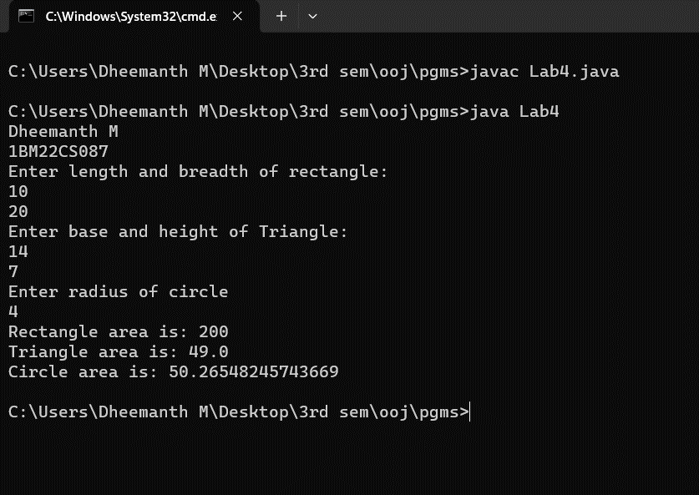

**LAB-5**

/*Develop a Java program to create a class Bank that maintains two kinds of account

for its customers, one called savings account and the other current account. The

savings account provides compound interest and withdrawal facilities but no cheque

book facility. The current account provides cheque book facility but no interest.

Current account holders should also maintain a minimum balance and if the balance

falls below this level, a service charge is imposed.

Create a class Account that stores customer name, account number and type of

account. From this derive the classes Cur-acct and Sav-acct to make them more

specific to their requirements. Include the necessary methods in order to achieve the

following tasks:

a) Accept deposit from customer and update the balance.

b) Display the balance.

c) Compute and deposit interest

d) Permit withdrawal and update the balance

Check for the minimum balance, impose penalty if necessary and update the balance. */

import java.util.Scanner;

class Account {

String customerName;

long accountNumber;

String accountType;

double balance;

Account(String customerName, long accountNumber, String accountType, double balance) {

this.customerName = customerName;

this.accountNumber = accountNumber;

this.accountType = accountType;

this.balance = balance;

}

void deposit(double amount) {

balance += amount;

System.out.println("\nDeposit of " + amount + " was successful. Balance: " + balance);

}

void displayBalance() {

System.out.println("\nAccount Number: " + accountNumber + "\nCustomer Name: " + customerName + "\nAccount Type: " + accountType + "\nBalance: " + balance);

}

void withdraw(double amount) {

if (amount <= balance) {

balance -= amount;

System.out.println("\nWithdrawal of " + amount + " successful. Updated balance: " + balance);

} else {

System.out.println("\nInsufficient funds. Withdrawal failed.\n");

}

}

}

class SavingsAccount extends Account {

SavingsAccount(String customerName, long accountNumber, double balance) {

super(customerName, accountNumber, "Savings", balance);

}

void interest(double rate) {

double interest = balance * rate / 100;

balance += interest;

System.out.println("\nInterest computed and deposited. Updated balance: " + balance);

}

}

class CurrentAccount extends Account {

double minimumBalance = 1000;

double serviceCharge = 50;

CurrentAccount(String customerName, long accountNumber, double balance) {

super(customerName, accountNumber, "Current", balance);

}

void withdraw(double amount) {

if (balance - amount >= minimumBalance) {

balance -= amount;

System.out.println("\nWithdrawal of " + amount + " successful. Updated balance: " + balance);

} else {

System.out.println("\nInsufficient funds. Withdrawal failed.\n");

}

}

void checkMinimumBalance() {

if (balance < minimumBalance) {

balance -= serviceCharge;

System.out.println("\nMinimum balance not maintained. Service charge imposed. Updated balance: " + balance);

} else {

System.out.println("\nMinimum balance maintained. Service charge not imposed. Updated balance: " + balance);

}

}

}

public class Bank {

public static void main(String[] args) {

System.out.println("Dheemanth M");

System.out.println("1BM22CS087");

Scanner s = new Scanner(System.in);

System.out.println("Savings Account: ");

System.out.print("Enter customer name: ");

String name = s.nextLine();

System.out.print("Enter account number: ");

long number = s.nextLong();

System.out.print("Enter initial balance: ");

double balance = s.nextDouble();

SavingsAccount = new SavingsAccount(name, number, balance);

System.out.println("Current Account: ");

System.out.print("Enter customer name: ");

name = s.next();

System.out.print("Enter account number: ");

number = s.nextLong();

System.out.print("Enter balance: ");

balance = s.nextDouble();

CurrentAccount = new CurrentAccount(name, number, balance);

int choice;

do {

System.out.println("\nSelect an option:");

System.out.println("1. Deposit to Savings Account");

System.out.println("2. Withdraw from Savings Account");

System.out.println("3. Compute Interest for Savings Account");

System.out.println("4. Deposit to Current Account");

System.out.println("5. Withdraw from Current Account");

System.out.println("6. Display Balances");

System.out.println("7. Exit");

choice = s.nextInt();

switch (choice) {

case 1:

System.out.print("Enter deposit amount for Savings Account: ");

double depositAmount = s.nextDouble();

savingsAccount.deposit(depositAmount);

break;

case 2:

System.out.print("Enter withdrawal amount for Savings Account: ");

double withdrawalAmount = s.nextDouble();

savingsAccount.withdraw(withdrawalAmount);

break;

case 3:

System.out.print("Enter interest rate for Savings Account: ");

double interestRate = s.nextDouble();

savingsAccount.interest(interestRate);

break;

case 4:

System.out.print("Enter deposit amount for Current Account: ");

double depositCurrent = s.nextDouble();

currentAccount.deposit(depositCurrent);

break;

case 5:

System.out.print("Enter withdrawal amount for Current Account: ");

double withdrawalCurrent = s.nextDouble();

currentAccount.withdraw(withdrawalCurrent);

break;

case 6:

System.out.println("\nFinal Balances:");

System.out.println("Savings Account:");

savingsAccount.displayBalance();

System.out.println("\nCurrent Account:");

currentAccount.displayBalance();

break;

case 7:

System.out.println("Exiting...");

break;

default:

System.out.println("Invalid choice. Please try again.");

}

} while (choice != 7);

}

}

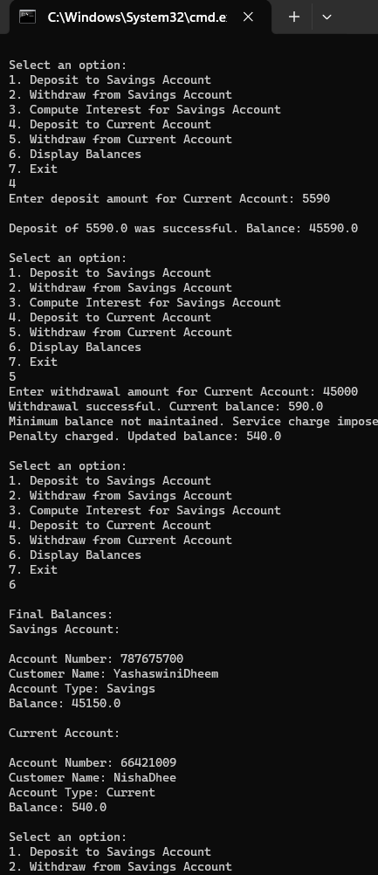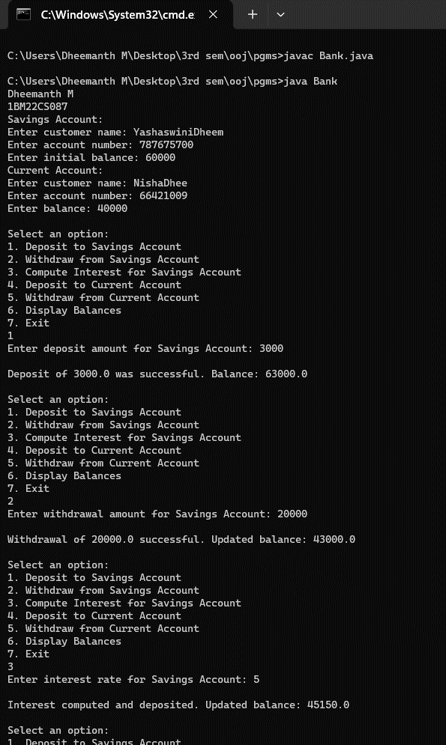.

**LAB-6**

/*Create a package CIE which has two classes- Student and Internals. The class Personal has members like usn, name, sem. The class internals has an array that stores the internal marks scored in five courses of the current semester of the student. Create another package SEE which has the class External which is a derived class of Student. This class has an array that stores the SEE marks scored in five courses of the current semester of the student. Import the two packages in a file that declares the final marks of n students in all five courses.*/

//CIE PACKAGE

//Student.java

package CIE;

public class Student {

    public String usn, name;

    public int sem;

    public Student(String usn, String name, int sem) {

        this.usn = usn;

        this.name = name;

        this.sem = sem;

    }

}

//Internals.java

package CIE;

public class Internals extends Student {

    public double[] internalMarks = new double[5];

    public Internals(String usn, String name, int sem, double[] internalMarks) {

        super(usn, name, sem);

        this.internalMarks = internalMarks;

    }

}

//SEE PACKAGE

//External.java

package SEE;

import CIE.Student;

public class External extends Student {

public double[] seeMarks = new double[5];

public External(String usn, String name, int sem, double[] seeMarks) {

super(usn, name, sem);

this.seeMarks = seeMarks;

}

}

//FinalMarks.java

import CIE.Internals;

import SEE.External;

import java.util.Scanner;

public class FinalMarks {

public static void main(String[] args) {

System.out.println("Dheemanth M");

System.out.println("1BM22CS087");

Scanner input = new Scanner(System.in);

System.out.println("Enter the number of students: ");

int n = input.nextInt();

input.nextLine();

Internals[] internals = new Internals[n];

External[] externals = new External[n];

for (int i = 0; i < n; i++) {

System.out.println("Enter details of Student " + (i + 1));

System.out.println("Enter USN: ");

String usn = input.nextLine();

System.out.println("Enter Name: ");

String name = input.nextLine();

System.out.println("Enter Semester: ");

int sem = input.nextInt();

input.nextLine();

double[] internalMarks = new double[5];

System.out.println("Enter Internal Marks for 5 courses: ");

for (int j = 0; j < 5; j++) {

System.out.println("Enter Internal Marks for Course " + (j + 1) + ": ");

internalMarks[j] = input.nextDouble();

}

input.nextLine();

internals[i] = new Internals(usn, name, sem, internalMarks);

}

for (int i = 0; i < n; i++) {

System.out.println("Enter SEE Marks for Student " + (i + 1));

double[] seeMarks = new double[5];

for (int j = 0; j < 5; j++) {

System.out.println("Enter SEE Marks for Course " + (j + 1) + ": ");

seeMarks[j] = input.nextDouble();

}

input.nextLine();

externals[i] = new External(internals[i].usn, internals[i].name, internals[i].sem, seeMarks);

}

System.out.println("\nFinal Marks of Students:");

for (int i = 0; i < n; i++) {

System.out.println("Student " + (i + 1) + " : USN: " + internals[i].usn + "\nName: " +

internals[i].name + "\nSemester: " + internals[i].sem);

for (int j = 0; j < 5; j++) {

System.out.println("Subject " + (j + 1) + ": " +

((internals[i].internalMarks[j]) + (externals[i].seeMarks[j] / 2)) + "\n");

}

System.out.println();

}

}

}

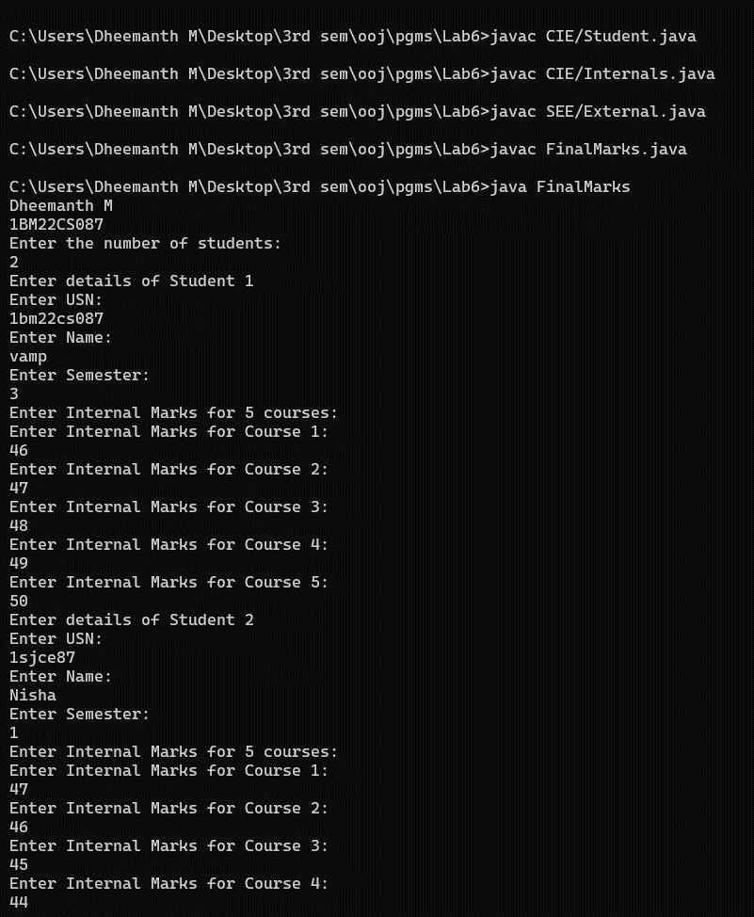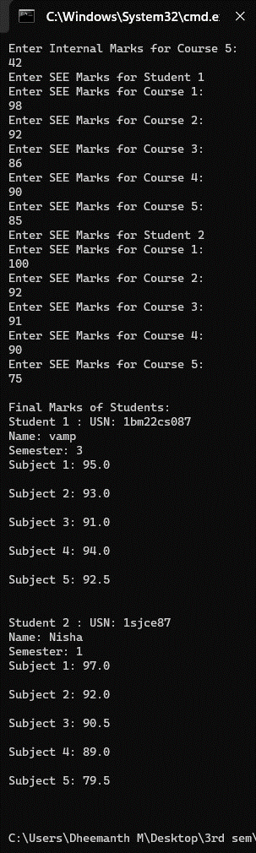.

**LAB-7**

/*Write a program that demonstrates handling of exceptions in inheritance tree.

Create a base class called “Father” and derived class called “Son” which extends the

base class. In Father class, implement a constructor which takes the age and throws

the exception WrongAge( ) when the input age<0. In Son class, implement a

constructor that cases both father and son’s age and throws an exception if son’s age

is >=father’s age.*/

import java.util.Scanner;

class WrongAge extends Exception {

public WrongAge(String message) {

super(message);

}

}

class Father {

Father(int fage) throws WrongAge {

if (fage < 0) {

throw new WrongAge("Age cannot be negative");

} else {

System.out.println("Father's age is " + fage);

}

}

}

class Son extends Father {

Son(int fage, int sage) throws WrongAge {

super(fage);

if (sage >= fage) {

throw new WrongAge("Son's age cannot be greater than father's age");

} else {

System.out.println("Son's age is " + sage);

}

}

}

public class Lab7 {

public static void main(String[] args) {

System.out.println("Dheemanth M");

System.out.println("1BM22CS087");

Scanner = new Scanner(System.in);

try {

System.out.println("Enter father's age:");

int fage = scanner.nextInt();

System.out.println("Enter son's age:");

int sage = scanner.nextInt();

Son = new Son(fage, sage);

} catch (WrongAge e) {

System.out.println("Exception caught: " + e.getMessage());

}

scanner.close();

}

}

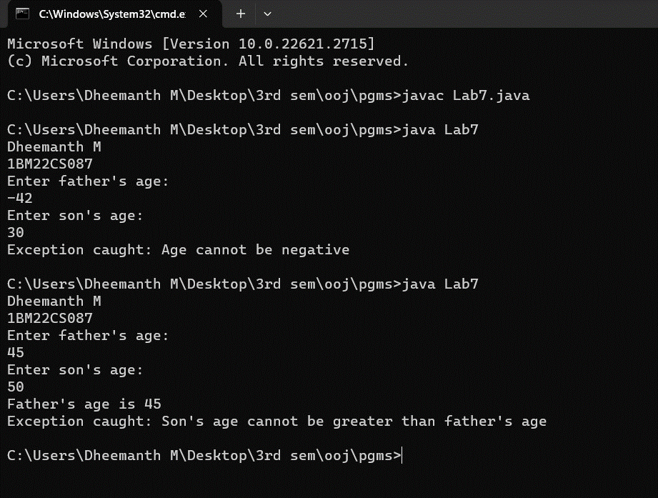.

**LAB-8**

/*Write a program which creates two threads, one thread displaying “BMS College of

Engineering” once every ten seconds and another displaying “CSE” once every two

seconds.*/

class BMS extends Thread {

public void run() {

for(int i=0;i<3;i++) {

System.out.println("BMS College of Engineering");

try {

Thread.sleep(10000);

} catch (InterruptedException e) {

e.printStackTrace();

}

}

}

}

class CSE extends Thread {

public void run() {

for(int i=0;i<10;i++) {

System.out.println("CSE");

try {

Thread.sleep(2000);

} catch (InterruptedException e) {

e.printStackTrace();

}

}

}

}

public class Lab8 {

public static void main(String[] args) {

System.out.println("Dheemanth M");

System.out.println("1BM22CS087");

BMS b = new BMS();

b.start();

CSE c = new CSE();

c.start();

}

}

